

**Costas Gerasimou**

**BA in restoration of works of art, antiquities and museology**

**Kokkinias 14, Larnaca, 6046 Cyprus**

**Tel: 0035799622990**

**Email:** [**costasgerasimou@gmail.com**](mailto:costasgerasimou@gmail.com)

**For: PSATHARIS AUCTIONS 7-1-25**

Evaluation of IVAN NIKOLAYEVICH KRAMSKOI painting by scientific diagnostic methods

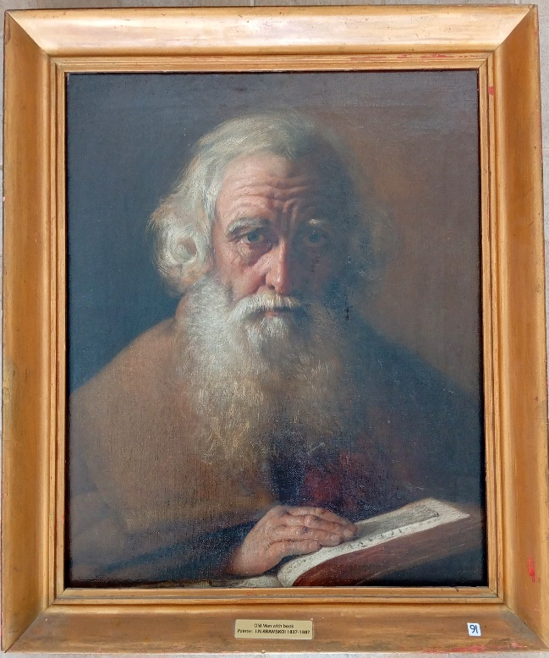

Scientific microscopic observation and images resulting from ultraviolet and infrared photography help to reveal important elements that are not visible in a painting.

The above scientific diagnostic methods have also been applied to the important painting by the famous Russian painter IVAN NIKOLAYEVICH KRAMSKOI (47 x 58 cm) entitled “Old man with book”.

Initially, these examinations show that the work is in very good condition. Examinations under ultraviolet radiation showed that the painting had some damage in the past and therefore had been restored, it is unknown when. During the aesthetic restoration work it appears that a significant part on the right side of the face, hair and pedigree was restored with a new painting.

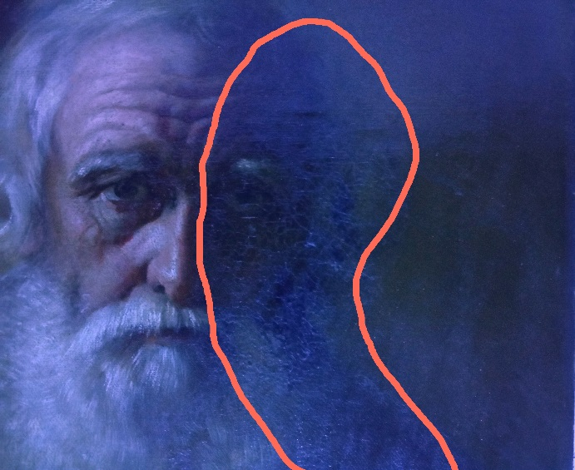 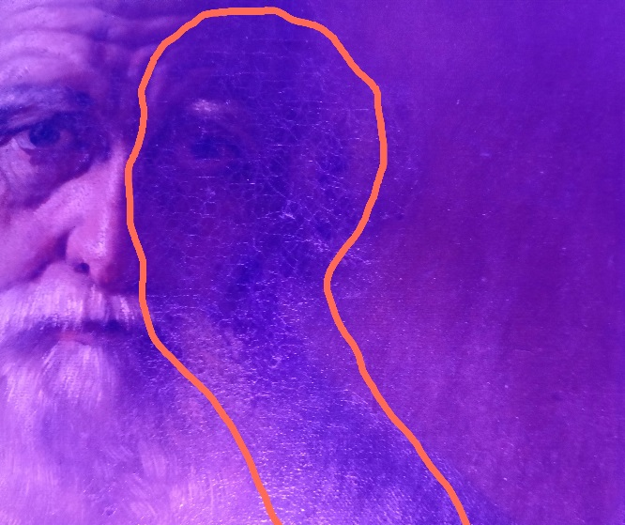

It is also difficult to identify the painter's signature with the naked eye. The painter's inscription is located at the bottom left corner in black paint covered by older micro-retouching and oxidation so that the letters are not legible. Infrared photography has revealed the following six-character inscription ‘1884 / KRAMSKOIV / **4 AΠPeΛb** »

 

Yours sincerely

Costas Gerasimou