PSATHARIS AUCTION HOUSE

RESULTS – The 29th AUCTION

The 29th auction of the Psatharis Auction House was marked by an unprecedented high sale for a masterful copy of Bellini’s Caterina Cornaro by an unknown artist

PRESS RELEASE – AUCTION RESULTS

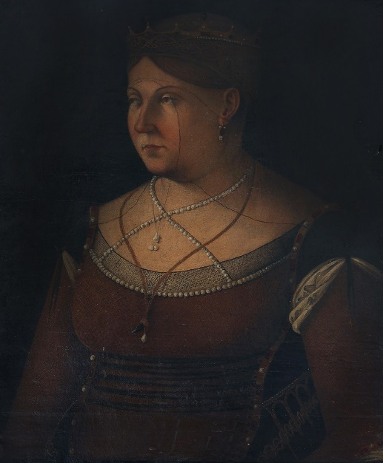
Unknown artist Caterina Cornaro – Queen of Cyprus

NICOSIA, THURSDAY 1st JULY, 2021 – The evening came alive amidst bidding for Caterina Cornaro, a masterful copy of the portrait by the Great renaissance master Gentile Bellini, which set an unprecedented record for a high sale by an unknown artist at auction. After ten bids the painting leapt past its estimate of €14.000 and sold for €37.295 becoming the highest-priced lot of the evening. Caterina Cornaro was sold to an undisclosed bidder. Usually, past auction results provide insight into an artist’s market trajectory. However no results are available for unknown artists on which to draw conclusions or make future predictions. Auction Founder and Top Executive Nikos Psatharis attributes the heated bidding for the said painting, which was sold abroad, to its outstanding quality and provenance. The painting belong to the Yiannis Perdios collection.
Overall the evening auction had great results. The 29th auction of the Psatharis Auction House was held at the open space area around the swimming pool in Nicosia’s The Landmark Hotel. The auction took in a total of €306.000. Of the 157 lots offered, the sale saw a sell through rate of 65 percent by lot (102 works sold) and 81 per cent by value. Summer Quartet by Andreas Charalambides sold within its estimates achieving €17.347, followed by Contemplation, a painting by Demetris Mytaras which fetched €16.748. Women on the Nile by Nicos Nicolaides achieved its high estimate and was sold for €9 570. Flowers in a Greek backdrop by Thanos Tsingos sold within its estimate fetching €8.015. Figures by Konstantinos Yiannikouris also sold within its estimates for €8.972.
Lower spenders bid against each other for Woman and Animal by Xanthos Hatzhisoteriou, which after 14 bids more than tripled its estimate of €2 000 fetching €6 221. The Lit Oven by Fotos Hatzisoteriou doubled its estimate of €1 500, and after ten bids reached €3 589. Christoforos Savva’ Red Landscape more than doubled its estimate of €2.000 and after seven bids reached €5.024. At the Port by Spyros Vassiliou also increased its price reaching after seven bids the amount of €5.024. Two landscapes by Telemachos Kanthos, Little houses with no door in the neighbourhood and Landscape sold within their estimates at €3589 and €7776 respectively. Stelios Votsis Without a Title achieved €2.033 after eight bids, and Gathering by Stass Paraschos fetched €5.263 after 10 bids.
The results of the 29th Psatharis Auction can be viewed at: www.psatharis-auctions.com.cy

