PSATHARIS AUCTION HOUSE
34th Auction Sale of Fine Art Artworks
Preview: 27 – 29 November 2023,
CLEOPATRA HOTEL, Nicosia - MACEDONIA HALL.
Auction: Wednesday 29 November 2023, 7:00 pm, CLEOPATRA HOTEL, Nicosia.
Psatharis Auction House announces the 34th Fine Art Auction to be held in Nicosia, at the Cleopatra Hotel, on Wednesday, November 29, 2023. The 34th auction is characterized by a collection of 137 items including many rare and special artworks offered to the art-loving public of Cyprus and abroad.
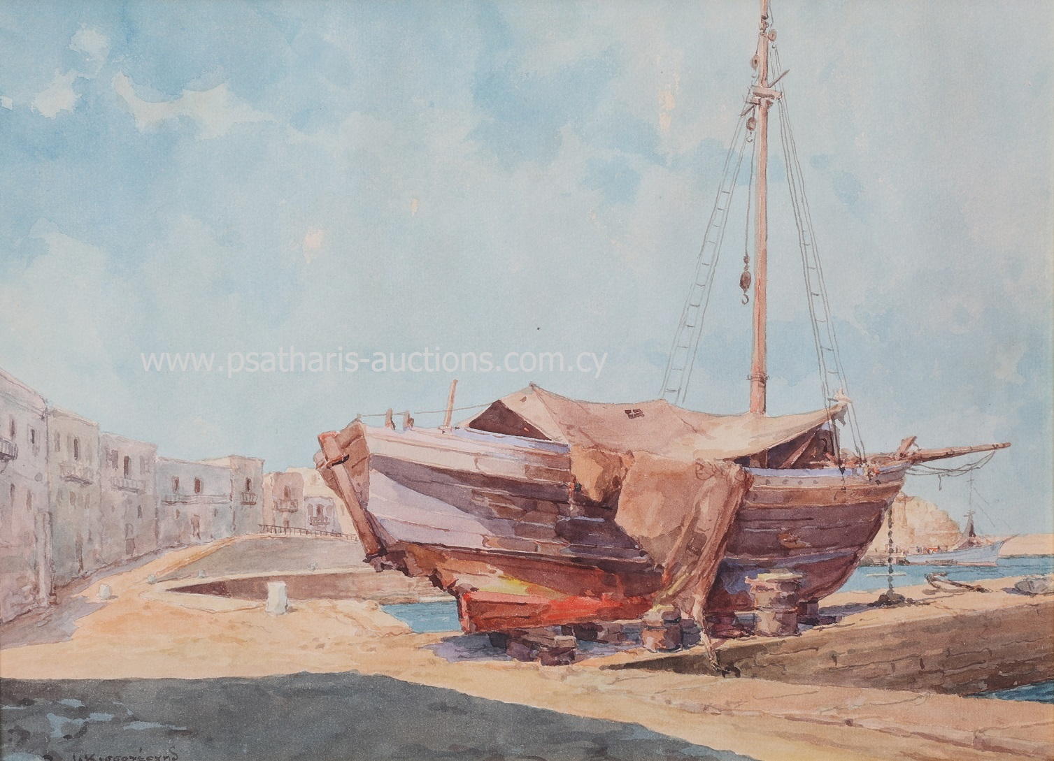
Ioannis Kissonergis (1889 - 1963) Boat in Kyrenia, Watercolour, 30 X 38 cm

As usual, Psatharis Auction House starts its catalog with watercolours, only this time they present, among others, 4 works by Ioannis Kissonergis, a view of the Port of Kyrenia with a boat dominating the foreground, a representation of the southeast side of the church of Panagia tis Asinou, an Agrikoia immersed in an orchard and a wild Peak of the Pentadaktylos Mountain Range. The collection of watercolours is enriched with two works by Angelos Giallinas, Corfu - Garitsa and Archaeological Site, a work by Skarvelis entitled Corfu - Penitsa as well as two works by Telemachos Kanthos,. a watercolour that presents a Landscape at dusk with simple horizontal colour surfaces that exacerbate the intensity of the work, giving it a strongly modern dimension and the second work is an early (1946) black-and-white gouache depicting Figures in the Women's Market. By the same artist, it is presented in number 44 entitled Morning, a landscape at sunrise with a huge sun rising over a church. The work has a warm coloor palette dominated by morning red and brown. Estimated at 8,000 - 13,000 euros.
After 4 characteristic works of Stelios Votsis and his imaginary world, the list continues with 4 woodcuts by Kostas Averkiou. The Cypriot self-taught artist surprises with his technical perfection in all the genres he deals with. The woodcuts present scenes of everyday life through the artist's analytical and descriptive lens. The public will encounter two more, paintings this time, works by Averkiou at the lots 35 and 36 of the catalog, The Forest and Maternal Affection.

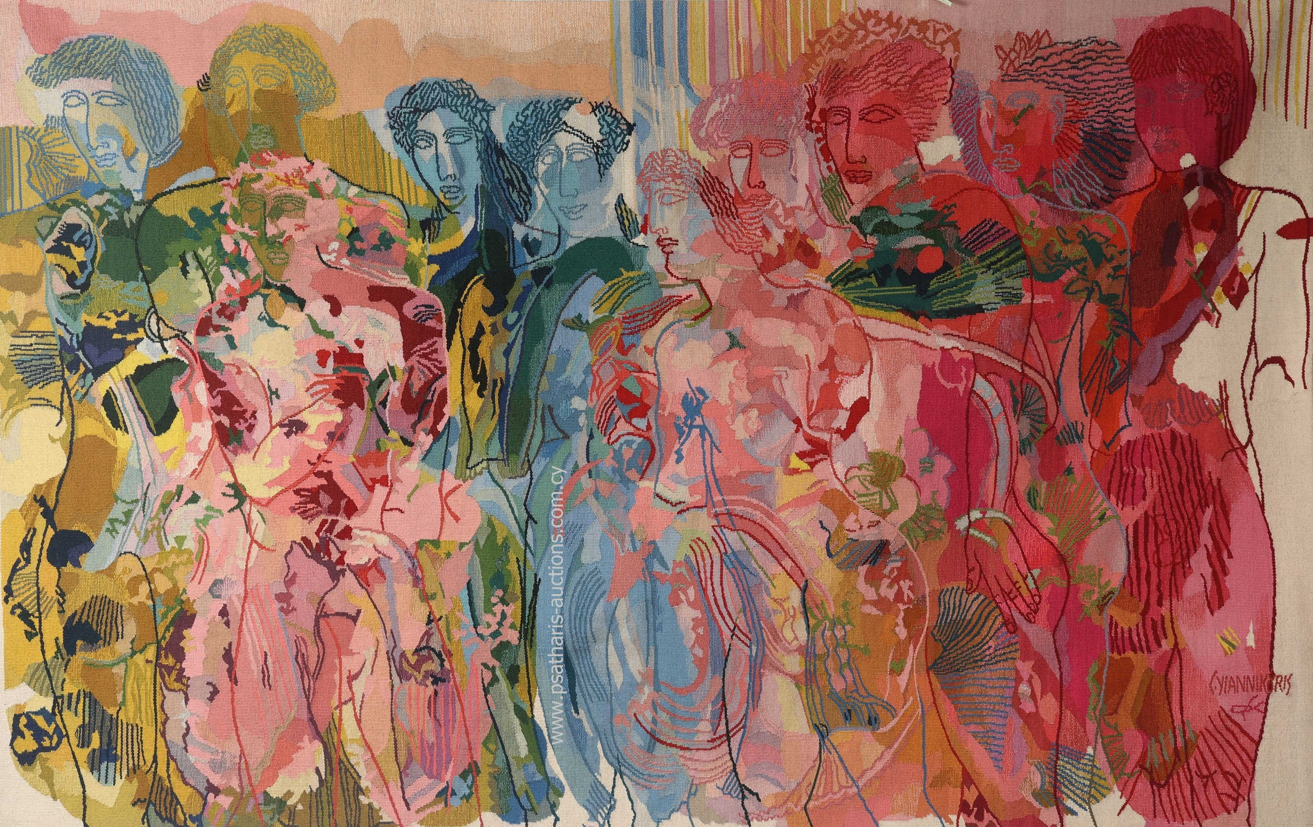 Constantinos Giannikouris (b. 1939) Untitled, Dated on back: 1984 - Tapestry, 163 X 261 cm

Two works by Constantinos Giannikouris are included in the November 29 auction, number 24 is a Composition from 2010, while number 52 is a large-scale tapestry from 1984 (163 X 261 cm). Two works by Mavroides are presented in the latest catalog of 2023, a Figure from 1998 and a Still Life with Fruit from 1988. The two works bear the characteristic broad strokes of the artist who builds almost sculptural volumes with his paint. Immediately below, the art-loving public can see two early works by Loukia Nikolaidou, a Portrait from 1927 and a scene from Anchorage (1933 - 1937).
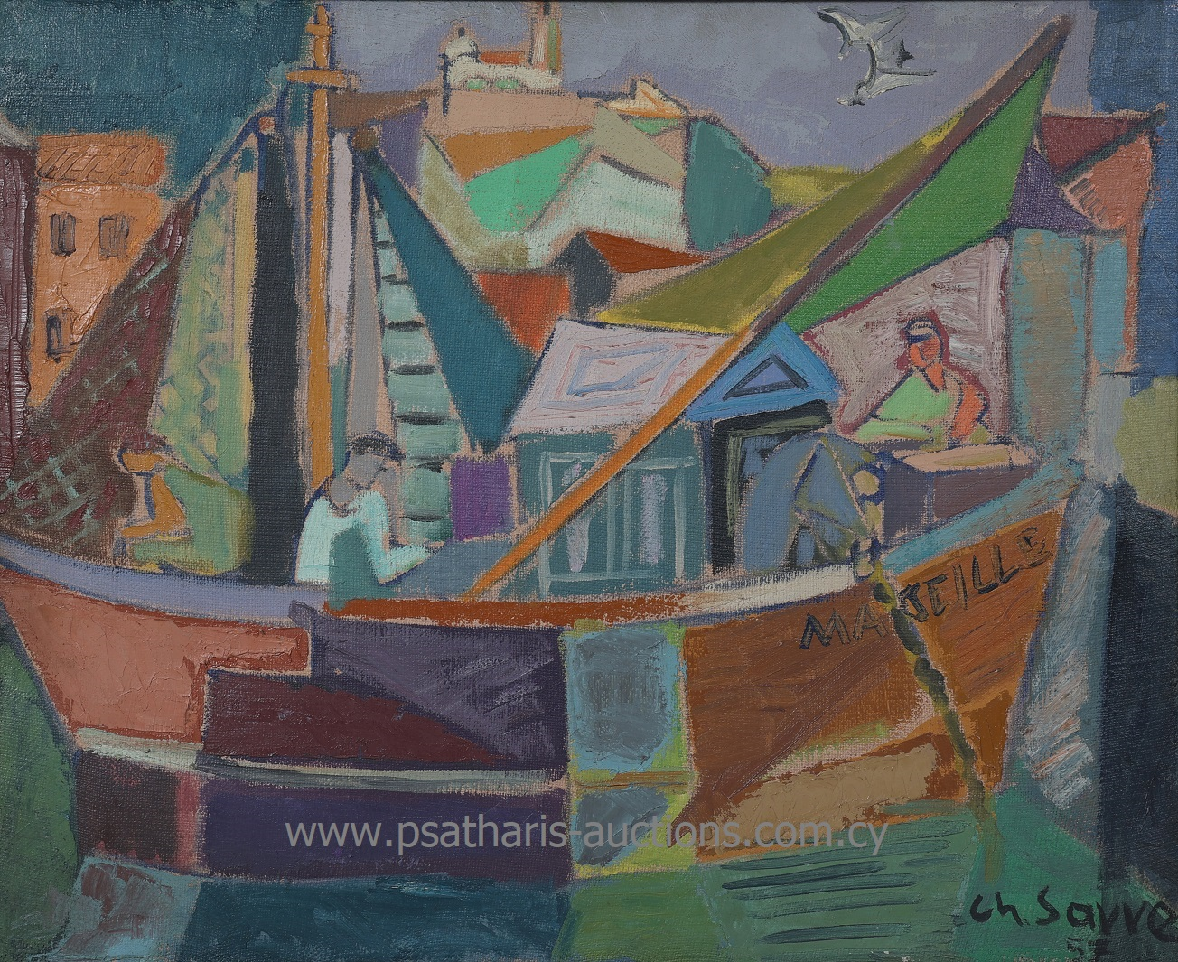
Christoforos Savva (1924 - 1968) Landscape in the South of France, 1957 Oil on canvas, 59 X 72 cm
Christoforos Savva's 1957 Landscape in the South of France is certainly one of the gems of the 34th auction. Measuring 59 x 72 cm, the work shows a boat with sailors anchored in a harbor. Sails, houses and masts create layers of colour that are reflected in the water and compose a picture full of life. Immediately after, a second work by Savvas, this time inspired by the world of theater, is presented at number 34 of the catalog and is dated 1957.
Carrying the bundles with the cart, the work of Michael Ch. Kashalos presents with his simplistic but detailed look the scene of the return of a family after the summer carrying the bundles on a cart. The figures are Doric and the cart seems to be carrying a load of gold, while the rendering of the vegetation in the landscape is deeply free and seems thoroughly modern.
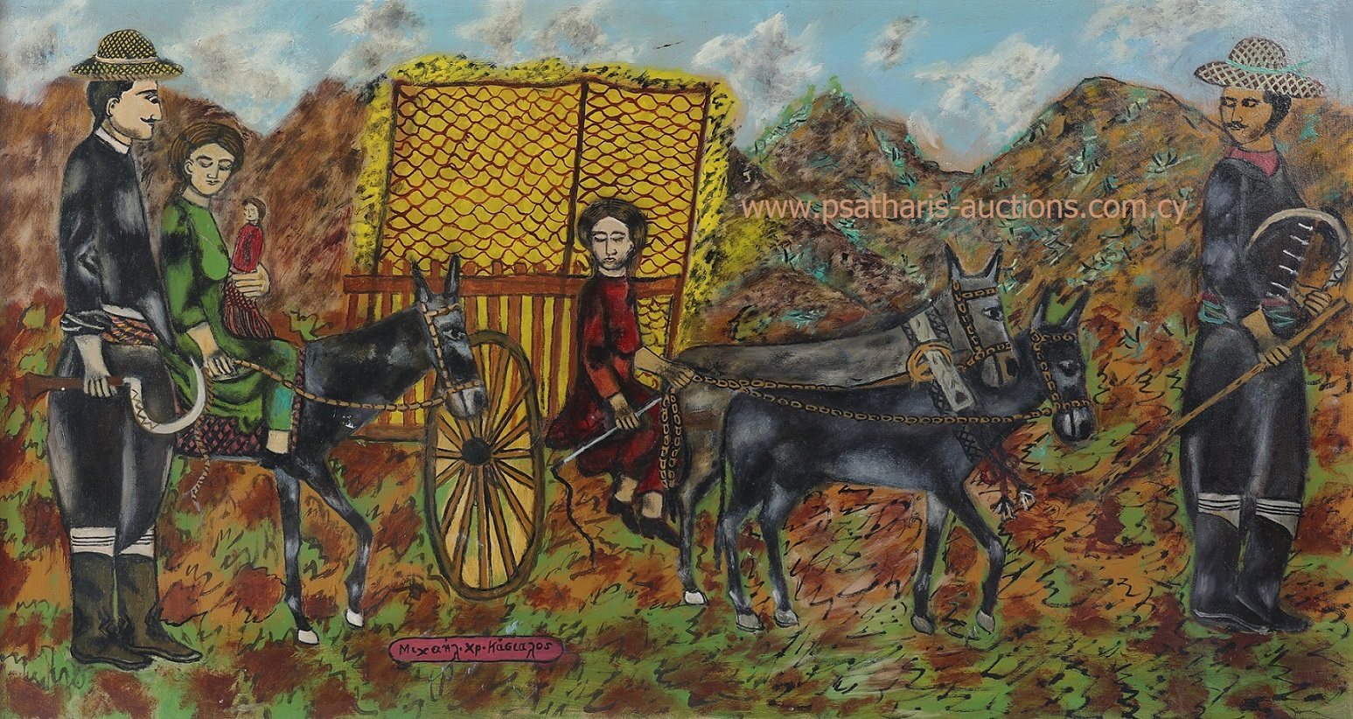
Michael Kashalos (1885 - 1974) Carrying the bundles with the cart, Oil on hardboard, 59 x 109 cm
The Winged Light by Alekos Fasianos depicts 6 golden birds shimmering on a red background full of life to symbolize the undying spirit. The work is accompanied by a certificate of authenticity and is estimated at 12,000 - 17,000 euros.  A Still Life with Bottles by Panagiotis Tetsis emits a golden light refracted by a yellow cloth behind the artist's composition. Alexandros Alexandrakis is presented in the catalog with the work Theros, a composition that captures the moment of the worker's drinking, painted with affection and respect.  Three works by the Hatzisotiriou brothers, two works with Xanthos Water Bearers and a Cypriot Landscape of Light, enrich the auction with a completely Cypriot light. While the two works by Giorgos Skoteinos recall the symbols of antiquity in a colorful and lively rendering. |  | 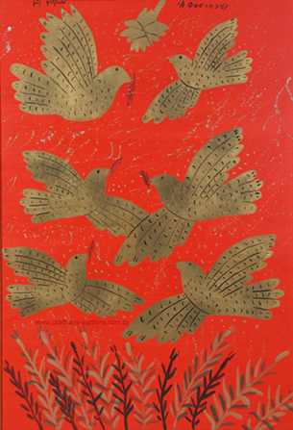  Alekos Fasianos (1935 - 2022) Winged Light  Acrylic and gold on canvas, 110 x 76 cm
Perhaps the most emblematic work of the exhibition dominates number 59, the portrait of Catherine Cornaro, Queen of Cyprus. The portrait measures 118 x 93 cm and is one of the largest known portraits of the queen. It is the work of a Venetian painter of the 16th century and is believed to derive from a now lost original by Titian. The work is supported by literature but also by its rarity and quality, it is estimated at 25,000 – 35,000 euros.
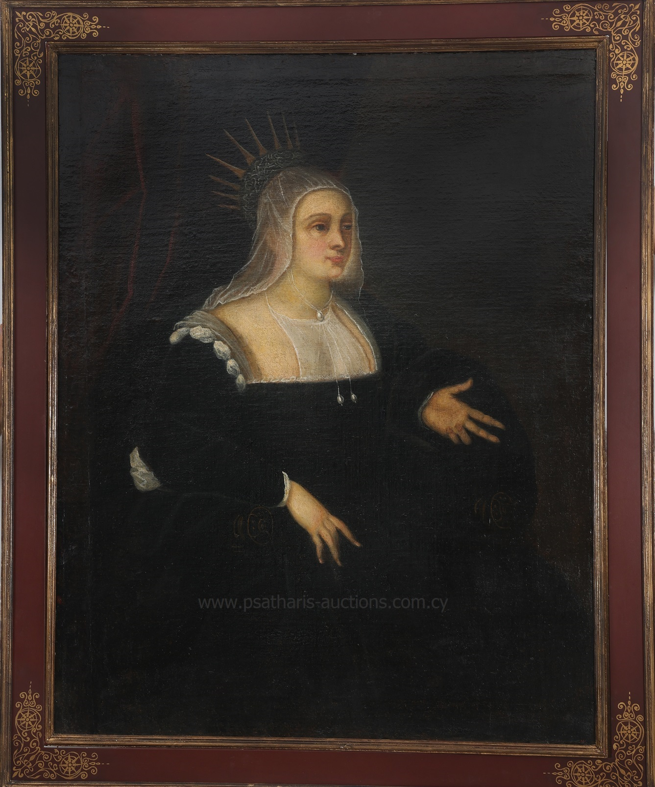
Venetian painter of the second half of the 16th century Portrait of Ekaterini Cornaro 118 Χ 93 cm
Four works by Alkis Keramidas occupy the numbers 60 to 63 of the catalog. These are two portraits and two landscapes with the artist's characteristic pastel colors and soft touches in the wooded landscapes. The first portrait shows a Cypriot girl while the second a girl who goes to school in the winter.
Numbers 84 to 86 present three works by Eleni Nikodimou with abstract compositions from the period when the artist lived in Paris.
Still lifes are one of the favorite subjects of artists both for their symbolism and for their aesthetic, compositional and color value. In addition to what we mentioned, we come across the Flowers in a Vase by Takis Frangoudis, the Vase with Flowers by Spyridon Papanikolaou, the Fruit Composition by Stas Paraskos and the Pears by Christos Christos.
Among other works, we mention the presence of paintings by Lefteris Economou, who is represented by four works, Glyn Hughes, Charilaos Dikaios, Andreas Charalambides, Mikis Phinikarides, Elli Mitzi and Andreas Karagian.
The auction list ends with seven sculptures by Filippos Yiapanis, Aristidis Patsoglou, Yiannis Moralis and Evangelos Moustakas.

The works in the catalog will be exhibited at the Cleopatra Hotel in Nicosia, in the Macedonia room on Monday 27 and Tuesday 29 November 2023, from 10 am. until 9 p.m. On Wednesday, the 29th, the exhibition will end at 4 pm. and at 7 p.m. the auction will begin which will be streamed directly from the digital platform www.invaluable.com. The public can express their interest both in the room and by phone or written offer.

General information
Psatharis Auction House
Tel.: 00357 24621109, 00357 99 564131
E-mail: psatharisauctions@cytanet.com.cy
Website: www.psatharis-auctions.com.cy

