PSATHARIS AUCTION HOUSE  33rd Auction Sale by Psatharis  WORKS BY CYPRIOT, GREEK  AND INTERNATIONAL ARTISTS  7 June 2023 at 8 pm  CLEOPATRA Hotel, Nicosia  PREVIEW  CLEOPATRA HOTEL – Nicosia  MACEDONIA HALL  Monday 5 June 10.00 a.m. - 9.00 p.m.  Tuesday 6 June 10.00 a.m. - 9.00 p.m.  Wednesday 7 June 10. a.m. - 5.00 p.m.  Auction sale: Wed. 7 June 2023, 8:00 pm | 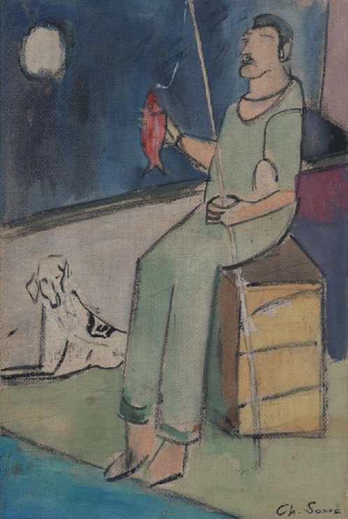  Chr. Savva, The fisherman, 1960 (Lot number 28)

Psatharis Auction House organizes its 33rd consecutive auction and presents a rich and quality collection of works of art at the Cleopatra Hotel from June 5 to 7, 2023. The collection includes 123 works by Cypriot and Greek artists that will be auctioned at 8:00 p.m. in the Macedonia Hall.
The auction will open, as usual, with a series of watercolours, 4 Egyptian landscapes by Spyridon Skarvelis and a vertical image of the sea of Corfu by Angelos Gialinas, 1893 showing two fishermen gathering nets from the sea. Here are 8 woodcuts by Telemahos Kanthos that represent the artist's various themes as they evolved from the 1940s and over the next three decades.
The woodcut Girl with the pitcher from 1941 with an estimate of 900 – 1500 euro is an early expression of the artist but a real document of the era for the society of Cyprus. Of particular interest is the oil painting on cardboard entitled Alona, by the same artist dated 1985. In this work, Kanthos depicts his ancestral home in the village of Alona through a more mature painterly way of expressing colour and shading. From number 15 to number 20 in the auction series, works by Stelios Votsis are presented that represent the special and distinct aesthetic, spiritual and creative criterion. No. 21 presents an ink on paper by Christoforos Savvas entitled Galery Apofasis depicting the gallery of the same name in Nicosia. The work, estimated at 4,500 to 6,500 euro, captures the graphic skill of the artist and describes the landscape with freshness and speed. Similarly, but this time in colour, Savva describes a Landscape of Cliouscat in the South of France, as he saw it in 1958. The work is on paper measuring 50 x 70 cm and gives with lively strokes the brilliance of the colours of the French landscape. In number 28, Christoforos Savva is represented with a third work, an acrylic on canvas depicting a Fish. The work is from 1960 and epitomizes the attempt to simplify the form that the artist was experimenting with during this period.

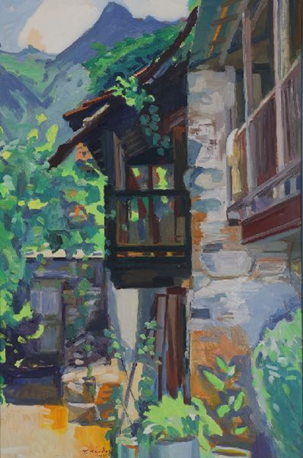  Τ. Kanthos, Alona, 1985 (Lot number 32) | 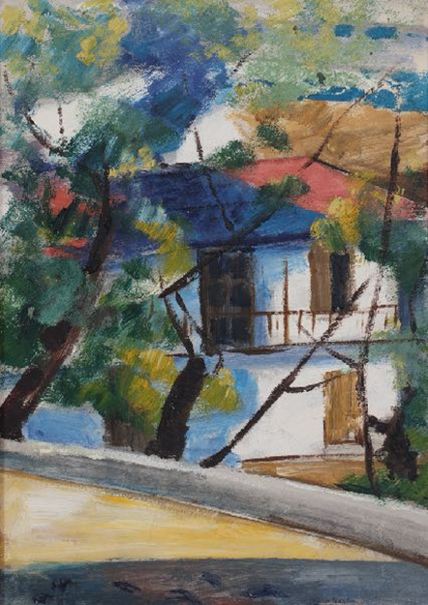 Α. Diamantis, Saint Theodoros, Agros (Lot number 50)

Three consecutive works by Epaminondas Thomopoulos adorn the 33rd auction of the House. In numbers 24, 25 and 26 of the catalogue are presented respectively the Bucolic, the Poppies Landscape and the Spring respectively. These are works of excellent aesthetic performance by the artist, which as a whole form a series of a post-romantic character.
Through the eyes of the artist, we can see the world of art better. In particular, when the artist studies by painting, another artist, we can detect elements that take us to the world of the poetry of Art. This is the case of Ioannis Kissonergis who renders in his own way the artwork Centaur and Mermaid by Andre Lubiac. The proposed work is of large dimensions, 186 X 132 cm., and is estimated at 10,000 to 15,000 euro.
Speaking of the special character and peculiar perception of art in Cyprus, the oldest name we can come across is that of Michael Chr. Kashalos. A painter, but also a sculptor and icon painter, Kashalos is perhaps the archetype of the folk artist on the island. In the 33rd auction, the artist is represented by 2 works. The first, number 36 in the catalogue, presents a classical three-level composition in a house interior depicting scenes from the Folklore Scenes. Characteristic are the Goblin figures with a goat's tail and horns. The work is made on canvas size 57 X 82 cm and is estimated at 20,000 to 27,00 euro.
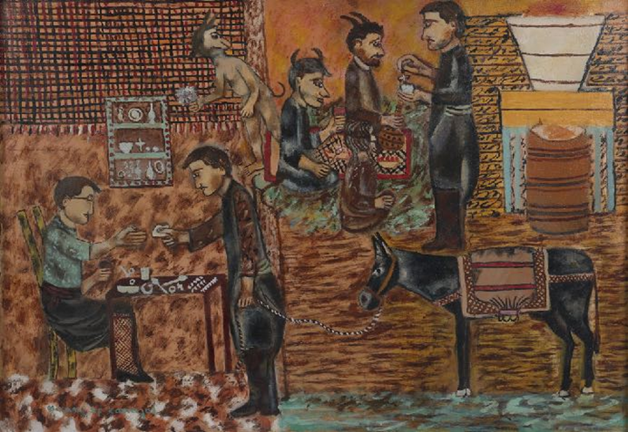
Michael Kashalos, Folklore Scenes (Lot number 36)

Immediately after, Virgin Mary of Mercy is presented, with a Western-oriented character and bright colours. The work is signed Michael Christou, one of the artist's rare signatures, and is created by oil on wood. Its size is 30 x 20 cm and it is estimated at 7,000 to 10,000 euro. Both works by Kashalos are accompanied by certificates of authenticity.
The brothers Fotos and Xanthos Hadjisoteriou with four works represent the space of the word - primitive art of capturing Cyprus and its world. In numbers 38, 39, 40 and 116 we find the fairy-tale world of Hadjisoteriou which recounts a reality that no longer exists.
An early work by Nitsa Hadjigeorgiou appears at number 41 of the catalogue and depicts an academic study of a male figure, just below, at number 43, a female figure is captured in 1982 by Kikos Lanitis in a batik technique. Giorgos Kotsonis is presented with special figures, as always, with the works Mythological and Female Portrait, while three works by Mikis Phinikarides continue, The Mirror of 1980, The Girls with Mersinia of 1996, and The Festival of 2002
Half way through, at number 50 we find the work of Adamantios Diamantis. It is titled Bright Landscape - Agios Theodoros Agros and depicts the artist's ancestral home. The painting is from 1966, has the number 34 in the artist's achieve file and is done in oil on hardboard. The dimensions of the project are 41 X 29.5 cm and it is estimated at 17,000 to 23,000 euro. The vibrancy of the colours and the playful character of the work convey to the art-loving public of the auction the opportunity to see and acquire a personal scene of the childhood memory of the leading Cypriot creator.
Three works that originate from the dream world of Alkis Keramidas give a special colour to the series of works. Path, House in the Countryside and Road in the Countryside take the viewer to the world of fantasy that continues immediately after his journey in the two works of Alekos Fasianos, Le Couple Amoureux and The cob smoker. The first is a gouache on paper, 55 X 75 cm and is estimated at 4,000-6,000 euro, while the second work is an acrylic on canvas, 52 X 49 cm and is suggested at 5,000 to 8,000 euro.

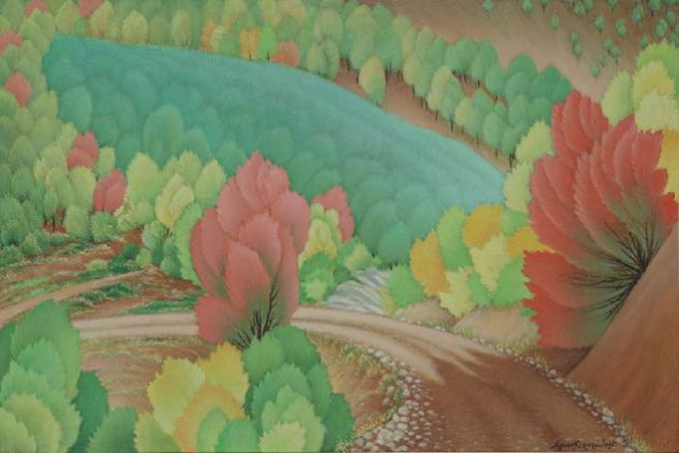
A. Keramidas Road in the countryside, 1969, (Lot number 55)
Polykleitos Regos always makes a strong presence, regardless of the size, technique and subject matter of his works. In the 33rd auction, the House proposes to its public three of his works, the Holy Trinity, from 1928, Aegina from 1927 and A House in Detroit from 1960. Through these works we recognize the sensitivity of the artist and the way he changes his painting characteristics depending on the mood and the landscape he captures.
Among the three works of Andreas Ladommatos, the 1993-1994 work from the series Stones and Water stands out. The work has dimensions of 127 X 107 cm and depicts a wild fig tree being thrown from a layer of river stones; it is estimated at 7,000 to 11,000 euro.
Impressive is the presence of Stas Paraskos' Theater Rehearsals of 1986 with male heads, female nudes and spectators who seem to be wearing masks of German expressionism. The bright colours and the decorative mood give the composition an air of critical perspective on social events.
Sensitive and strictly private is the Portrait of a Young Man by Yannis Tsarouhis with lot number 71 in the auction series. Drawing, pencil on paper, 39 X 20 cm, dated May 1, 1969 and estimated at 1,500 to 2,000 euro. Equally delicate is the pencil on paper entitled Female figures (Cent Sirenes de mer pour un homme) by Maria Loizidou, a 1987 work crafted in Paris, one of the rare appearances of works by the acclaimed artist at auctions.
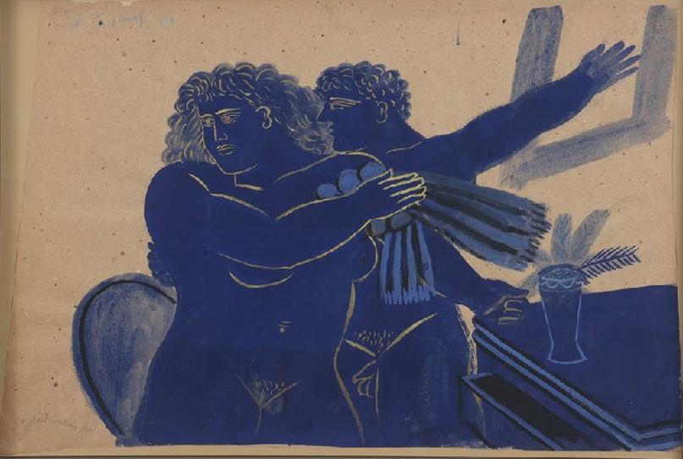
Α. Fassianos, Le Couple Amoureux, 1983 (Lot number 56)
In addition, we note the Nude of D. Georgantas, the Figure of Giorgos Gounaropoulos with an estimate of 3,000 – 5,000 euro, the Composition of D. Mytaras, the Priestesses of A. Charalambides, with an estimate of 6,000 – 10,000 euro, the Portrait of a Woman by S. Vikatos, the impressive Untitled of D. Yeros. The Composition of S. Karavouzis and the Composition of T. Manolidis add to the series of still lifes of the auction, while the works of Th. Pantaleon and E. Sakayan enrich the dreamy images. The auction includes, among many others, Kostas Averkiou with two works, Andreas Tomblin with a series of three works, Andreas Makariou, Glyn Hughes, Giorgos Mavroidis, Christos Christou, Giorgos Erotokritos and John Corbidge.

Aristidis Patsoglou's bronze Nude sculpture, numbered 3/5 is a small jewel at the close of the auction together with the three sculptures by Moralis and the composition in limestone by Petousis.  The works in the catalogue will be exhibited at the Cleopatra Hotel in Nicosia, in the Macedonia Hall on Monday 5 and Tuesday 6 June, from 10 am. until 9 p.m. On Wednesday, June 7, the preview will close at 5 p.m. and at 8 p.m. the auction sale will begin which will be streamed live from the online actionl platform www.invaluable.com  The public can express their interest both in the room and by phone or written offer.  Live on-line bidding, is available at: www.invaluable.com  General information  Psatharis Auction House  Tel: 00357 24621109, 00357 99 564131  E-mail: psatharisauctions@cytanet.com.cy  Website: www.psatharis-auctions.com.cy | 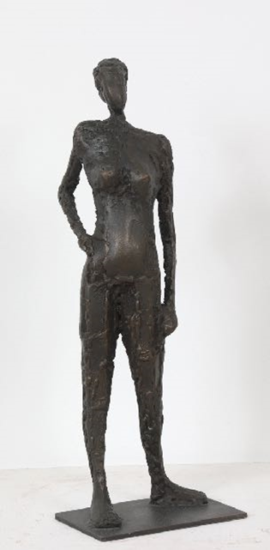  Α. Patsoglou, Nude (Lot number 117)

