PSATHARIS AUCTIONS
32nd Auction Sale by Psatharis
Preview: 28th – 30th November 2022, Cleopatra Hotel, Nicosia
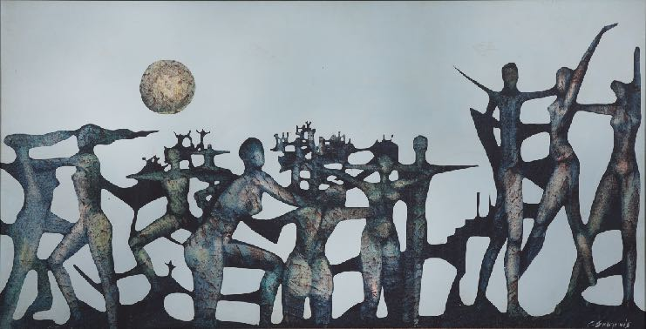
Auction: Wednesday 30th November 2022, 7:00 p.m, Cleopatra Hotel, Nicosia
G. Skotinos, Terracotta Era, 1969 (cat. n. 14)
Once again, the Psatharis Auction House has collected a rich group of artworks that will be presented at the Kleopatra Hotel from November 28th to 30th as part of the 32nd auction. The collection includes over 130 works by Cypriot and Greek artists and a remarkable selection of maps of Cyprus.
The auction will open with watercolours, 2 Egyptian landscapes by Spyridon Skarvelis and a view of the countryside of Corfu by Angelos Giallinas. The relatively large work of Giallinas moves in a warm colour palette that freshly conveys the idyllic landscape of the island. Equally interesting and important is the watercolour presented by the auction catalogue at number 8. The early work by Stelios Votsis was presented at an exhibition in Larnaca in 1949. The work was created in 1948 before the artist left for his studies in
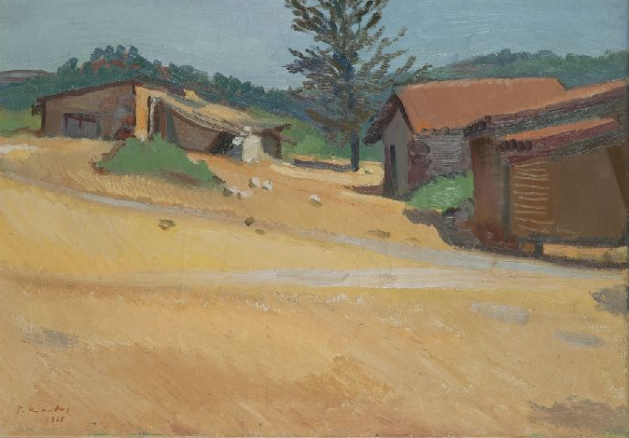
England. The rarity and quality of the work make it worthy of attention. After the watercolour in question, the auction catalogue presents 5 more works by the painter from Larnaca.
T. Kanthos, Hamospita, 1968 (cat.n. 73)
Three other watercolours of highly importance are the two works by Kostas Oikonomou. Threshing is an early work from 1948, while Pomegranates is from 2000. The third watercolour is by Telemachus Kanthos entitled Walnut with shadows. It is a work of 1941 and renders the texture of the landscape through the well-known colour sensitivity of the artist. A work by Kanthos can also be found at number 73 of the catalogue. Hamospita is a 1968 oil on canvas work depicting three rural houses in a valley that turns golden after the summer harvest, surrounded by the green pine trees of the region of Alona with is ​​the artist's birthplace. The work was presented at the exhibition that inaugurated the historic Argo Gallery in 1970 and was published in the exhibition's catalogue mentioned above. By the same artist, 3 engravings are presented that elaborately depict the suffering of the Cypriot people.
Worthy of attention are, among others, the two works by Giorgos Skoteinos that the 32nd Psathari Auction proposes to its public (catalogue n.14 and 15). These are two post-surrealist works, the Archaic VI of 1973 and the Terracotta Era of 1969. The works of Skoteinos are symbolic compositions, and the deep concerns of the artist are expressed visually with his unique technique.

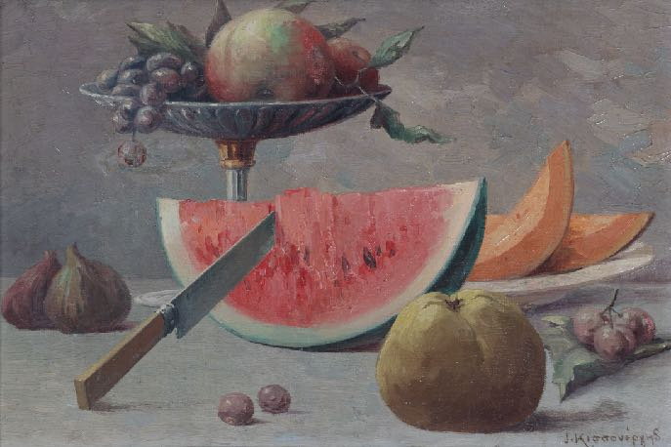
I. Kissonergis, Composition (cat.n. 24)
The art-loving public will have the opportunity to admire rare and special artworks, also in this auction, such as the Still life with watermelon and bottle by Andreas Ladommatos, a work of 1969. Even rarer is the still life by Ioannis Kissonergis. It is entitled Composition and shows a table with late summer fruits, watermelon, cantaloupe, figs, grapes and quince. The artist's still lifes, are not often seen, but in this particular we recognise the sweet, pastel colours of his palette and his well-known metaphysical depiction of light and volumes. Three other still lifes add a special touch of colour to the auction collection. The Composition by Giorgos Mavroidis, a work of 1980, The Vase with Flowers and Apples by Pericles Pantazis and the Composition with Fruits by Stass Paraschos. The work of Pantazis is part of the classic depiction of still lifes of the second half of the 19th century and has been published in two well-known bibliographic manuals. The two still lifes of Hector Doukas are a continuation of this aesthetic. The work of Mavroidis that we mentioned depicts a plant in a pot with rough strokes, whereas the work Composition of Stass declares a pervasive harmony as the synthetic and colour intelligence of the artist stimulates the senses of art lovers.
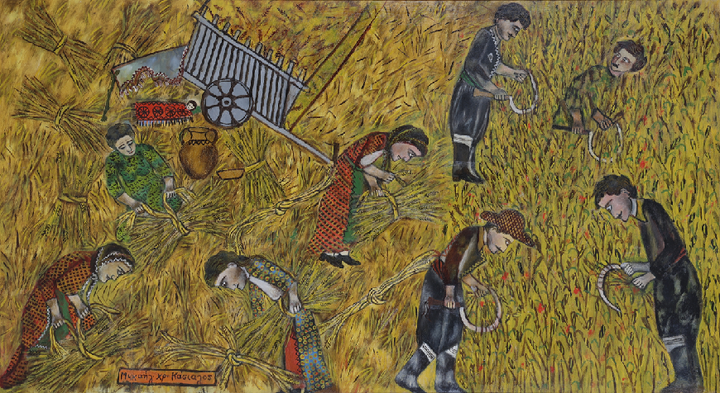
A similar mood is evoked by the light from the elaborated small-scale work of Polycleitos Rhegos. The Cottage in Mykonos presents a small white house with a chimney and a blue window immersed in the colours of the sky, stones and plants with a painted texture characteristic of Regos.
M. Ch. Kassialos, Theros (cat.n. 41)
A prominent position in the auction catalogue is, without a doubt, the work of Michael Kashialos, both for its quality and content. Theros (harvest) is part of the artist's works that describe scenes of daily life in the Cypriot countryside of the mid-20th century. As in other pieces of the same character, the painter, with his particular style, refers to the details and impressions that only the man who lived in the countryside can capture. The blooming field with wheat and poppies is harvested by the men while the bales are prepared by the women, dressed in the traditional attire of Cyprus except of the young woman in the green dress. A ceramic jug holds the valuable water while a headband scarf spreads over a piece of wood, and the end of the carriage forms the makeshift tent for an infant sleeping under a red blanket with black roses. Kassialos' glances, colours and narration, move and create stories of a world that no longer exists.
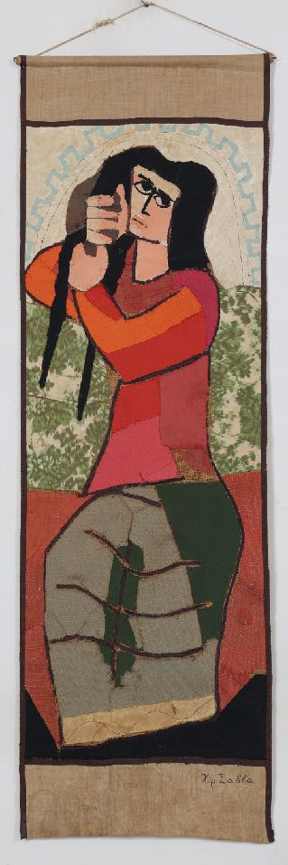
Several remarkable portraits feature prominently in this collection. Four human portraits and one bird of A. Fassianos add colour and quality to the collection through the artist's characteristic compositional specificity. Works such as Spyridon Papanikolaou's atmospheric Self-Portrait of 1947, Thalia Flora Karavia's two pastels depicting her nieces, together with Gounaropoulos's Figure and Foinikarides' painting Walk are in dialogue with earlier works such as the portrait of the scholar N. Schiavoni, work of Aristides Oikonomou, the Grandmother of Spyridon Vikatos and the portrait of a man by Mariathes Drakontaidis, the first female painting graduate of the School of Fine Arts. Two paintings of Andreas Charalambidis are part of this auction (catalogue n. 68 and 69), two compositions with a medieval atmosphere and archaic forms characteristics of his production. A special mention deserves the portrait of Christoforos Savvas, which presents The Braiding of a young woman's hair. The work is done with the technique of textile patchwork that the artist often used. The bright colours and harsh lines reflect his particular aesthetic, while the girl's big eyes remind of a Fayum portrait of Hellenistic times. This work was of particular importance to the artist who was photographed in front of it on the occasion of his exhibition at the Paphos Municipal Hall in 1964. An abstract composition of bodies in pastel by Savvas appears in the catalogue - number 110. Other compositions with the human figure enrich the catalogue with the works of V. Germenis, Nikos Kourousii, Andrea Karagian, Edouard Sakagian, Angelos Panagiotou, Apostolos Geralis and others.

Ch. Savva, Vroullisma (cat.n. 44)

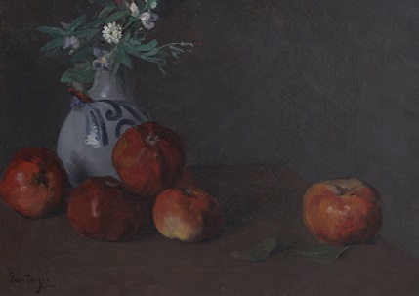
Works such as the Composition by Dimitris Mytaras, the Nude by Theodoros Manolidis, the Interior with a dog by the same artist, the Washbasin and the Pigeons by Angelos Panagiotou seal the quality and collecting interest of the 32nd auction of the Psatharis Auctions. Along with the above, and of equal collecting value, are the four luminous works of Lefteris Oikonomou, the romantic work of Spyros Vassiliou, the works of Alki Keramida, Glyn Hughes and John Corbridge.

The collection of the 32nd auction is enriched by the sculptures of Yiannis Moralis, two of which are in a particularly limited edition, the Erotic 11/16 and the Meeting of Friends 11/25.

Pericles Pantazis (1849 - 1884)

Vase with flowers and apples (cat. n. 34)
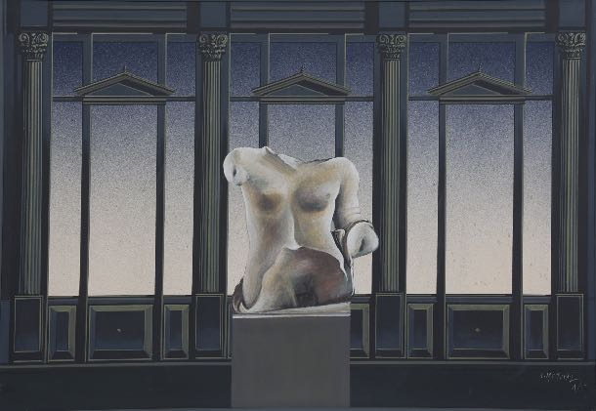
D. Mitaras, Composition (cat.n. 70)

It is essential to mention the 46 maps of Cyprus of the 32nd auction. These are works in rare condition and quality from the 16th to the 19th century, printed by the most famous cartographers of each era. Seven of them close the rich printed catalogue while the rest are posted on the house's website, www.psatharis-auctions.com.cy and www.invaluable.com.

The art works of the current auction will be exhibited at the Cleopatra Hotel in Nicosia on Monday 28th and Tuesday 29th November, 10:00 - 21:00. The auction will be held on Wednesday 30th at 19:00 and will be on live streaming on the digital platform www.invaluable.com. The public can choose to bid in the room, on the web and with written offers.

General Information
Psatharis Auctions
Telephone n.: 00357 24621109, 00357 99 564131
E-mail: psatharisauctions@cytanet.com.cy
Web: www.psatharis-auctions.com.cy και www.invaluable.com

